Team Project 2 Final Report

Part I: “How to Run”

1. The system will ask the user to enter “the number of problems in the quiz”, “the number of criteria in each problem”, and “the number of students in the class”.

2. After typing in those numbers mentioned above, the system will create an Excel file, named “studentQuizRecords.xlsx”, inside the default folder.

3. Please fill in the Excel file with the description & weights of all criteria and scores of students in every criterion. (We create our own data in the sample file, named “StudentQuizRecordSample.xlsx”).

4. The system will ask the user if the Excel file is completely filled. (Note: please add our sample Excel file to your default folder). If the user enters “y” or “Y”, the system will read the Excel file and generate quiz reports (.docx files) for all students in the default folder.

5. In addition, the system will ask the user if she/he needs a special analysis report. If the user enters ”y” or “Y”, the system will generate a .docx file, named “SpecialAnalysisReport.docx”. If the user enters ”n” or “N”, the system will end.

Part II: UML Class Diagram

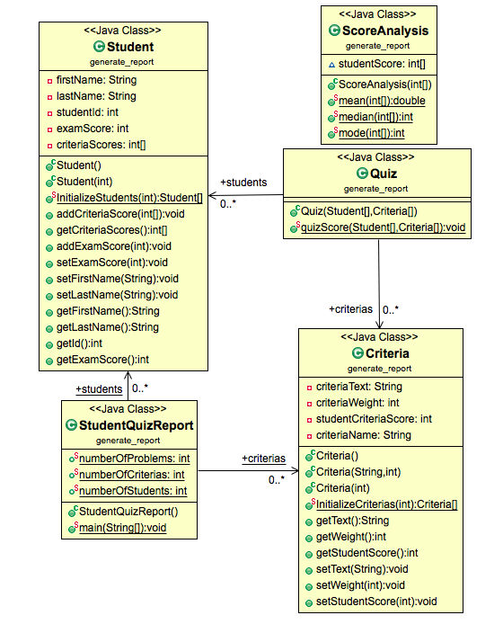

Part III: Tests & Converge

We perform JUnit Tests on all classes except StudentQuizReport class. Those JUnit Tests are 100% but the entire converge is 28% since our separation is not good.

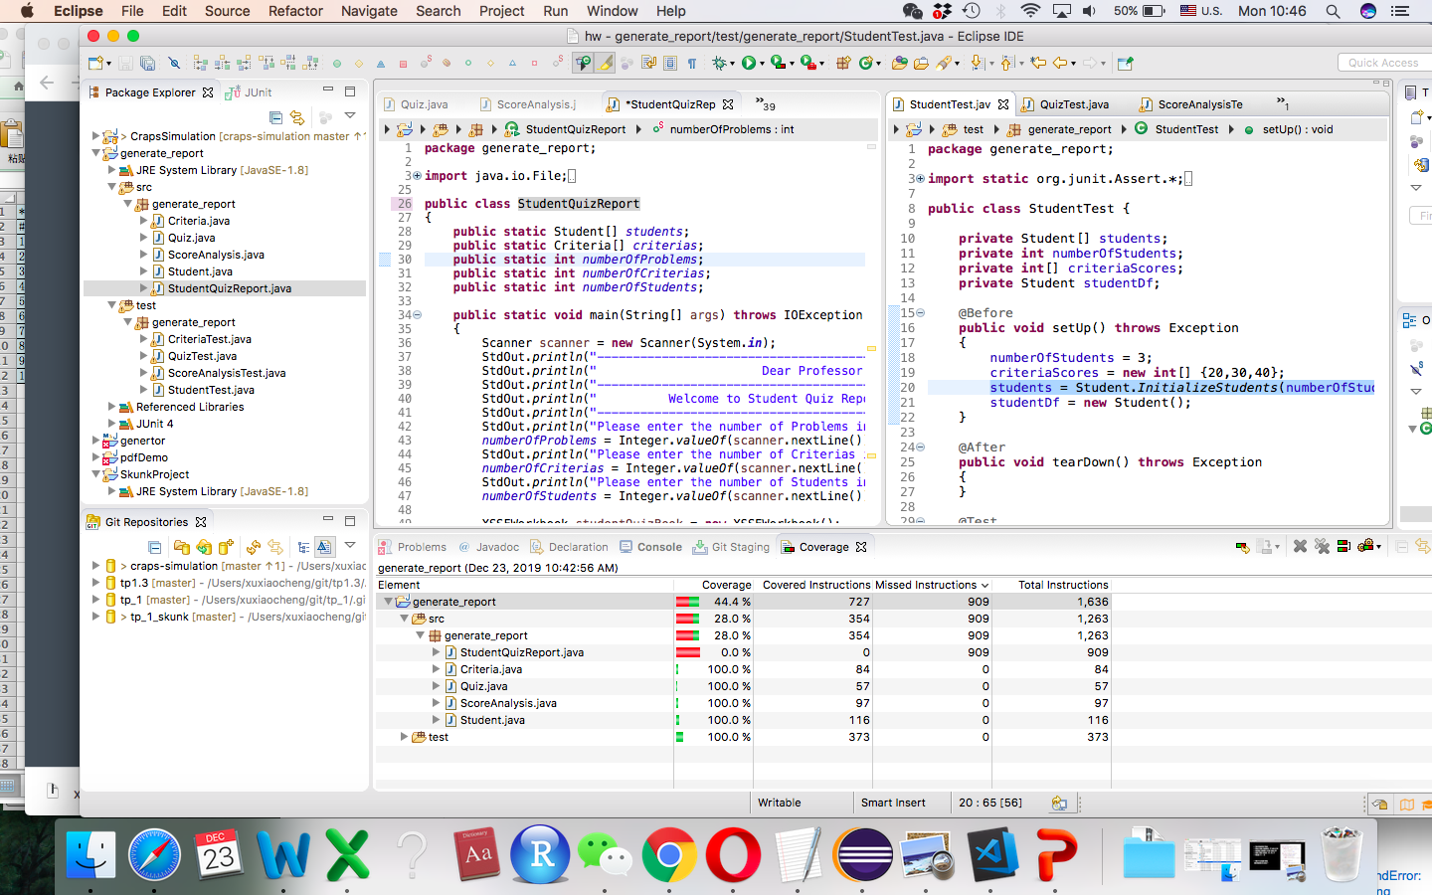

Part IV: Extra Credits

We also add a special quiz analysis report for the professor. This report will analyze the quiz performance of all students in the class and show the statistic analysis results, such as mean, median, and mode of quiz scores.

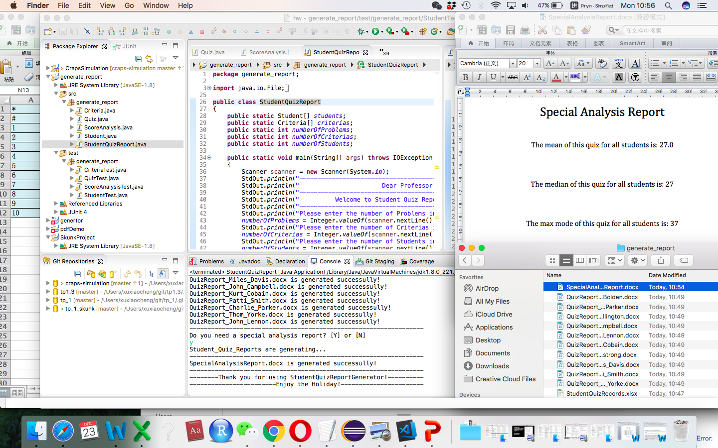

Part V: Additional Illustration of Working Processes

1. Ask & Enter requested numbers:

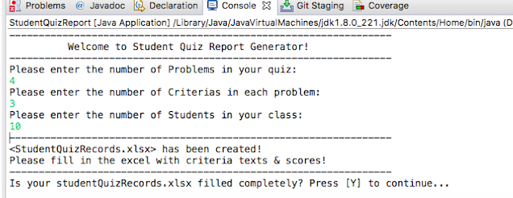

2. System creates an Excel file, named “studentQuizRecords.xlsx”, in default folder.

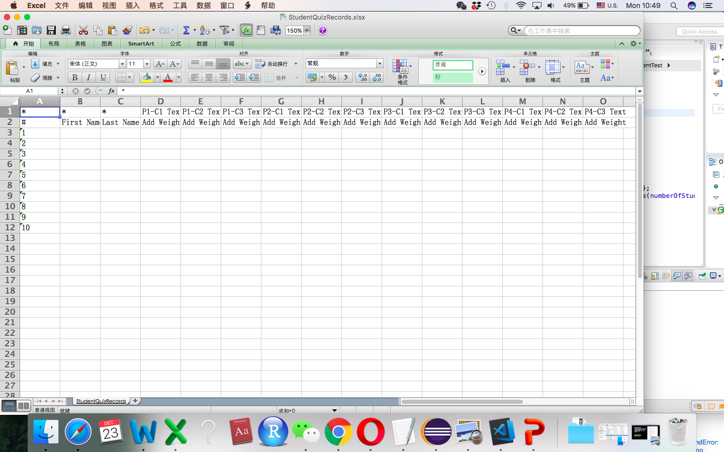

3. Please fill in the Excel file with the description & weights of all criteria and scores of students in every criterion. (We use our own data in the sample file, named “StudentQuizRecordSample.xlsx”. Please add our sample Excel file to your default folder!!!)

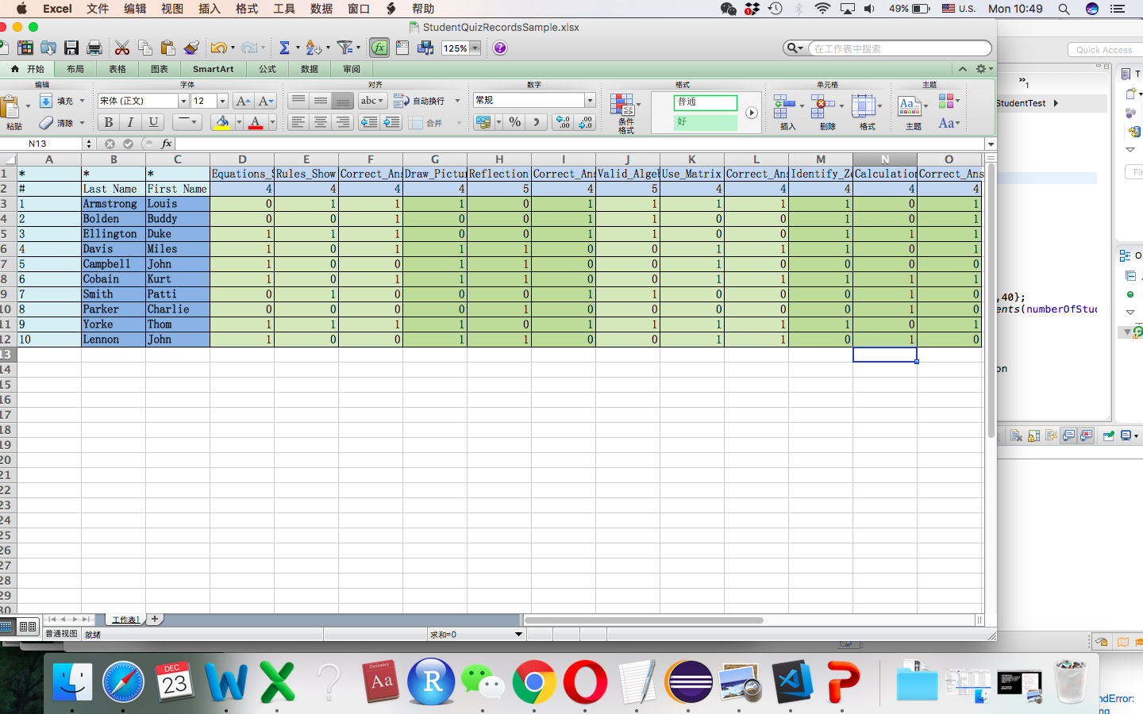

4. The system will ask the user if the Excel file is completely filled. If the user enters “y” or “Y”, the system will read the Excel file and generate quiz reports (.docx files) for all students in the default folder.

